Prüfungsprogramm 4.KYU

SUWARIWAZA
Shomenuchi Kiawase | 1 | Ikkyo Omote
Shomenuchi Kiawase | 2 | Ikkyo Ura

TACHIWAZA
Shomenuchi Kiawase | 3 | Ikkyo Omote
Shomenuchi Kiawase | 4 | Ikkyo Ura
Shomenuchi Kiawase | 5 | Nikyo Omote
Shomenuchi Kiawase | 6 | Nikyo Ura
Shomenuchi Kiawase | 7 | Ikkyo Ura | Kakarigeiko (2 Uke)
Katatetori Aihanmi | 8 | Shihonage Omote
Katatetori Aihanmi | 9 | Shihonage Ura
Katatetori Aihanmi | 10 | Iriminage
Katatetori Aihanmi | 11 | Kotegaeshi
Katatetori Aihanmi | 12 | Udekimenage
Katatetori Aihanmi | 13 | Uchikaitennage
Katatetori Gyakuhanmi | 14 | Ikkyo Omote
Katatetori Gyakuhanmi | 15 | Ikkyo Ura
Katatetori Gyakuhanmi | 16 | Kotegaeshi
Katatetori Gyakuhanmi | 17 | Iriminage
Ryotetori | 18 | Shihonage Omote
Ryotetori | 19 | Shihonage Ura
Ryotetori | 20 | Tenchinage
Ryotetori | 21 | Genkeikokyunage
Ryotetori | 22 | Udekimenage
Ryotetori | 23 | Kiriotoshi (Chinshin)
Katate Ryotetori | 24 | Udekimenage
Katate Ryotetori | 25 | Kotegaeshi | Kigata
Ushiro Ryotetori | 26 | Kotegaeshi
Ushiro Ryotetori | 27 | Shihonage
Katatori Menuchi | 28 | Kotegaeshi
Katatori Menuchi | 29 | Shihonage
Yokomenuchi | 30 | Shihonage
Yokomenuchi | 31 | Iriminage
Yokomenuchi | 32 | Kotegaeshi

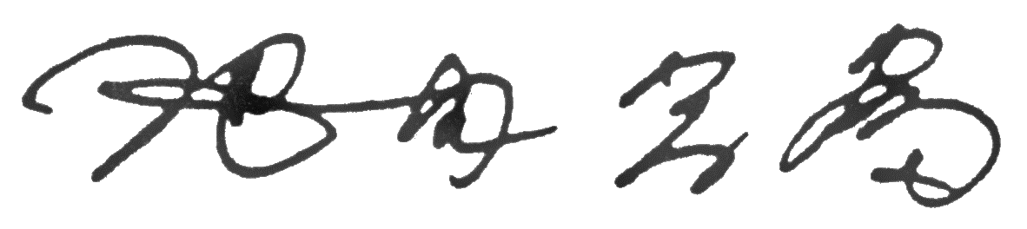23.10.1999/M. Ikeda

