Prüfungsprogramm 3.KYU

SUWARIWAZA
Shomenuchi Kiawase | 1 | Ikkyo Omote/Ura
Shomenuchi Kiawase | 2 | Nikyo Omote/Ura
Shomenuchi Kiawase | 3 | Iriminage | bis Osae
Katatetori Gyakuhanmi | 4 | Shihonage | Hanmi Hantachi

TACHIWAZA
Shomenuchi Kiawase | 5 | Iriminage
Shomenuchi Kiawase | 6 | Kotegaeshi
Shomenuchi Kiawase | 7 | Sumiotoshi
Shomenuchi Kiawase | 8 | Aikigoshi
Shomenuchi Kiawase | 9 | Shihonage
Shomenuchi Kiawase | 10 | Udekimenage
Shomenuchi Kiawase | 11 | Uchikaitennage
Shomenuchi Kiawase | 12 | Ikkyo Ura | Kakarigeiko (3 Uke)
Katatetori Aihanmi | 13 | Ikkyo Omote/Ura
Katatetori Aihanmi | 14 | Nikyo Omote/Ura
Katatetori Aihanmi | 15 | Sankyo Omote/Ura
Katatetori Aihanmi | 16 | Shihonage
Katatetori Aihanmi | 17 | Uchikaitensankyo
Katatetori Gyakuhanmi | 18 | Uchikaitensankyo
Ryotetori | 19 | Shihogirikokyunage | Irimi Tenkan Sabaki
Ryotetori | 20 | Torifunekokyunage | Irimi Tenkan Sabaki
Katate Ryotetori | 21 | Genkeikokyunage | Tanren Tenkan Sabaki
Katate Ryotetori | 22 | Kiriotoshi | Kigata
Katate Ryotetori | 23 | Maeotoshi
Katate Ryotetori | 24 | Hikiotoshi
Katate Ryotetori | 25 | Kotegaeshi | Kigata
Ushiro Ryotetori | 26 | Tenchinage
Ushiro Ryotetori | 27 | Genkeikokyunage
Katatori Menuchi | 28 | Iriminage
Katatori Menuchi | 29 | Ikkyo
Yokomenuchi | 30 | Kotegaeshi | Ushiroashi Irimi Tenkan
Yokomenuchi | 31 | Ikkyo | Kirioroshi
Yokomenuchi | 32 | Ipponseoi | Sankakutai

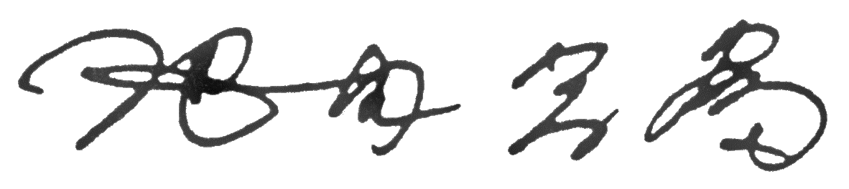23.10.1999/M. Ikeda

